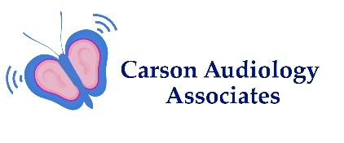
Pediatric History Form
Patient Name________________________________________ Birth Date _____________ Age ______
Person Completing Form_______________________________ Relationship to patient _____________

Primary Concerns: (Please circle Yes or No)
Do you feel this child has a hearing loss?__________________________________ Yes No
Are you concerned about this child’s speech or language development? _________ Yes No
Please describe concern: _________________________________________________________
______________________________________________________________________________
Pregnancy or Birth complications, please list if applicable ______________________________________
______________________________________________________________________________
Please describe any family history of hearing loss before age 40 ________________________________
______________________________________________________________________________
Communication and Developmental History: (Please circle Yes or No)
Difficulty with pronunciation_____________________________________________ Yes No
Language development concerns_________________________________________ Yes No
Difficulty listening or understanding conversation____________________________ Yes No
Attention problems at school_____________________________________________ Yes No
Other developmental delays_____________________________________________ Yes No
Hearing and Middle Ear History: (Please circle Yes or No)
Previous hearing testing?_______________________________________________ Yes No
Balance or coordination difficulties?_______________________________________ Yes No
Please describe_______________________________________________________
___________________________________________________________________
Tinnitus or noises in the ears?___________________________________________ Yes No
Exposure to hazardous noise?___________________________________________ Yes No
Allergies?____________________________________________________________ Yes No

Middle Ear Health:
Number of ear infections_______ Have they resolved?______ At what age?______
P.E. tubes placed? _____ When?_________ By what Doctor?__________________
History of ear pain?_____________________________________________________ Yes No

General Observations:
Does child respond to voices or environmental sounds? ________________________ Yes No
Does child startle to loud noises? __________________________________________ Yes No
Does child search to find the source of sounds? ______________________________ Yes No

Physical and General Health Conditions: Please List __________________________________
______________________________________________________________________
Current Medications and/or Supplements: Please List _________________________________
_______________________________________________________________________
Acknowledgement
I acknowledge by my signature below that I have been given the opportunity to review the Updated Notice of Privacy Practices for the office of Dr. Nanci Campbell. I have been informed that my personal information will not be shared with anyone without my permission.

Guardian Signature _____________________________
Relationship __________________________________
Date signed ___________________________________

