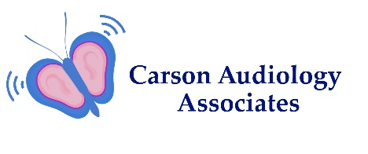

Adult History Form Page 1 of 2
Patient Name________________________________________ Birth Date _____________ Age ______
Current Concerns (circle all that apply)
Hearing Loss Right Ear Left Ear Both Ears None Sudden Onset
Tinnitus Right Ear Left Ear Both Ears None
Dizziness Unsteadiness Vertigo Lightheaded None
Ear Pressure Right Ear Left Ear Both Ears None
Ear Pain Right Ear Left Ear Both Ears None
Ear Draining Right Ear Left Ear Both Ears None

Do You Wear Hearing Aids? (circle all that apply)
Right Ear Left Ear Both Ears None
Are they working properly? Right Left Both Neither
Year purchased _______ Brand if known _______________ Are they in warranty? Yes/No

Noise Exposure History (circle all that apply)
Gunfire Airplanes Chainsaws Military Construction Jackhammers
Hunting Factory Work Power Tools Other____________________________
Was hearing protection worn at all times? Earplugs/Earmuffs/Both/Neither

Have you ever had: (circle all that apply)
Chronic Earaches Ear Surgery Sudden Hearing Loss Eye Surgery Kidney Disease Arthritis Diabetes Bleeding Problems Osteoporosis Hypertension Dizziness Family History of Hearing Loss Meningitis Head Trauma Heart Disease Allergies

Page 2 of 2
Social History
Do you avoid social occasions because of difficulty hearing? Yes/No
Do you find yourself having to ask people to repeat themselves? Yes/No
Do you sometimes hear words but do not understand? Yes/No
Do you have difficulty understanding in noisy places? Yes/No
Have you been told that you speak loudly? Yes/No
Do others complain that the TV is too loud? Yes/No
Are some voices easier to understand than others? Yes/No
Do you find loud sounds bothersome? Yes/No
What bothers you most about your hearing? ________________________________________
________________________________________________________________________________
________________________________________________________________________________

Please list all medications and supplements:
Name____________Dosage__________Frequency________HowTaken_______________________________________________________________________________________________________________________________________________________________________________________________________________________________________________________________________________________________________________________________________________________________________________________________________________________________________________________________________________________________________________________
Please list any chronic medical conditions:
_______________________________________________________________________________________________________________________________________________________________________________________________________________
Acknowledgement
I acknowledge by my signature below that I have been given the opportunity to review the Updated Notice of Privacy Practices for the office of Dr. Nanci Campbell. I have been informed that my personal information will not be shared with anyone without my permission.
Patient Name __________________________________
Patient Signature _______________________________
Date signed ___________________________________

Guardian Signature _____________________________
Relationship __________________________________
Date signed ___________________________________
Refused to sign_________________________________

